PROJECT

OBSTACLE AVOIDING CAR Using ARDUINO UNO

This car was made using Arduino Uno board and an Ultrasonic sensor as major components.

To drive the car a two sets of geared motor which was driven by motor driver connected to Arduino for input.

Whenever an obstacle comes in front of Ultrasonic sensor at a particular distance a specific command gets executed which drives specific motors.

Circuit and Working

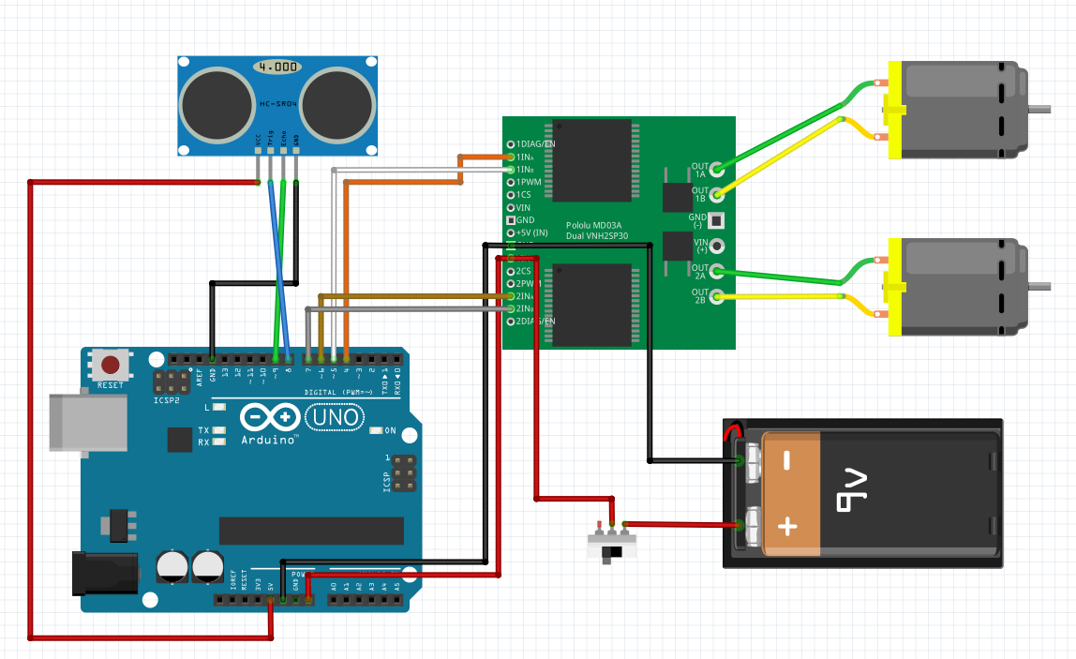

PIN CONNECTIONS

Ultrasonic sensor has four pins namely GND, VCC, ECHO, TRIG GND and VCC are connected to GND and +5V of the Arduino respectively, ECHO and TRIG pins are connected to pin no.8 and pin no.9 respectively.

Motor driver has many pins but we use only 10 pins from it namely 1INa, 1INb, GND, Vin, 2INa, 2INb, OUT 1a, OUT 1b, OUT2a, OUT2b.

The out pins are connected to motors as shown in the circuit, GND and VCC are used for power supply for the driver, rest of the pins are used for input to the driver board from Arduino.

WORKING

Whenever an object comes under the range of ultrasonic sensor a specified condition gets executed in Arduino board as per the input from Ultrasonic sensor which gives input to motor driver and hence drives the motor in the particular direction.

If no object is in front of Ultrasonic sensor the car will move forward in straight direction.

CODE

inttP=8;

inteP=9;

intrevrht=6;

intfowrht=7;

intrevlft=4;

intfowlft=5;

floatspd=343;

floattD;

floatping;

voidsetup(){

 pinMode(tP,OUTPUT);

 pinMode(eP,INPUT);

 pinMode(revlft,OUTPUT);

 pinMode(revrht,OUTPUT);

 pinMode(fowlft,OUTPUT);

 pinMode(fowrht,OUTPUT);

**Serial**.begin(9600);

}

voidloop(){

 digitalWrite(tP,HIGH);

 delayMicroseconds(2000);

 digitalWrite(tP,LOW);

 delayMicroseconds(15);

 digitalWrite(tP,HIGH);

 delayMicroseconds(10);

 ping=pulseIn(eP,HIGH);

 ping=ping/1000000;

 tD=spd*ping;

 tD=tD/2;

 tD=tD*100;

**Serial**.println(tD);

 if(tD>18.){

 digitalWrite(fowlft,HIGH);

 digitalWrite(fowrht,HIGH);

 digitalWrite(revlft,LOW);

 digitalWrite(revrht,LOW);

 }

 if(tD<18.){

   digitalWrite(fowlft,LOW);

   digitalWrite(fowrht,LOW);

   digitalWrite(revlft,LOW);

   digitalWrite(revrht,LOW);

   delay(500);

   digitalWrite(fowlft,LOW);

   digitalWrite(fowrht,LOW);

   digitalWrite(revlft,HIGH);

   digitalWrite(revrht,HIGH);

   delay(500);

   digitalWrite(fowlft,LOW);

   digitalWrite(fowrht,LOW);

   digitalWrite(revlft,LOW);

   digitalWrite(revrht,LOW);

   delay(100);

   digitalWrite(fowlft,LOW);

   digitalWrite(fowrht,HIGH);

   digitalWrite(revlft,LOW);

   digitalWrite(revrht,LOW);

   delay(100);

   digitalWrite(fowlft,HIGH);

   digitalWrite(fowrht,LOW);

   digitalWrite(revlft,LOW);

   digitalWrite(revrht,LOW);

   delay(500);

  }

}

